Exercise No. : 1

Date : 14/10/2020

**AIM:**

To write a python program for printing the calendar of a given month and year

**PROGRAM:**

import calendar

year=int(input())

month=int(input())

if ((year>999 and year<10000) and (month>=1 and month<=12)):

print(calendar.month(year,month))

else:

print("INVALID INPUT")

**LINK :**

http://103.53.53.18/mod/vpl/forms/edit.php?id=229&userid=1639

**OUTPUT:**

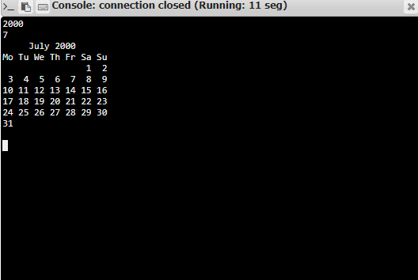

**RESULT:**

The program has been successfully executed and verified.